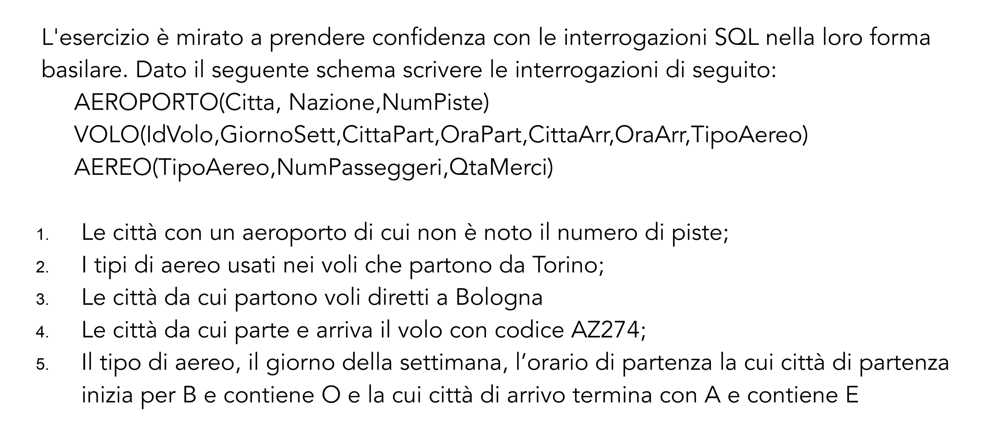

1-SELECT Città

FROM AEROPORTO

WHERE NumPiste = null

2-SELECT A.TipoAereo

FROM AEREO as A

WHERE A.CittaArr = Torino

3- SELECT V.CittàPart

FROM VOLO as V

WHERE V.CittaArr = “Bologna”

4- SELECT V.CittaArr, V.CittaPart

FROM VOLO as V

WHERE V.IdVolo = “AZ274”

5- SELECT TipoAereo, GiornoSett, OraPart, CittaPart

FROM VOLO

WHERE CittaPart LIKE ‘B%O%’ AND CittaArr LIKE ‘%E%A’